**PREPARATION INSTRUCTIONS**

**CO2 Laser Skin Resurfacing Eyelids**

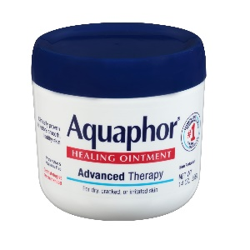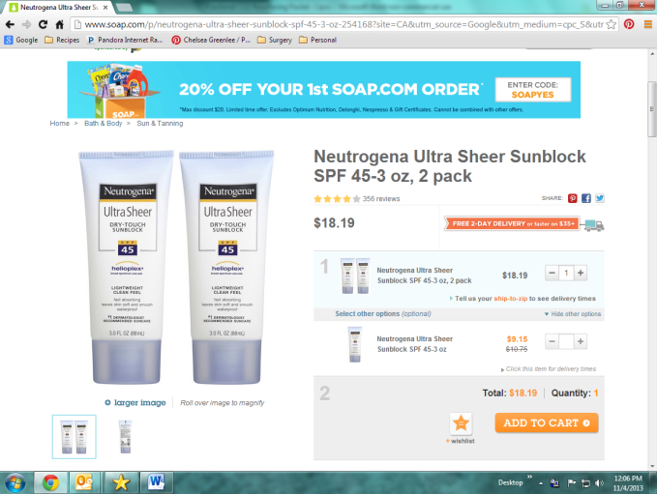

**Items you will need:**

1. Sunblock Water Based Type (1st ingredient is Water) - Neutrogena Ultrasheer
2. Facial Cleanser- Cetaphil or CeraVe gentle cleanser
3. Aquaphor healing ointment

**One Week Prior**

1. Discontinue over the counter retinoid/BHA/AHA topical skin care products if you use them.
2. Practice using sunblock every morning.

**Day of Procedure**

1. Take any thyroid, heart or blood pressure medications you regularly take with a small sip of water.
2. Wash your face but DO NOT WEAR ANY LOTIONS, SUNBLOCK OR MAKEUP.
3. Wear loose, comfortable clothing.
4. If you wear glasses, bring a case for storage. Do not wear contacts.

***Please see back for after surgery instructions***

**AFTER LASER CARE**

1. Wash your hands frequently and before each time you cleanse the treated area.
2. Cleaning your face
   1. Wash the resurfaced area (2) two times per day with your GENTLE CLEANSER and pat dry. The first wash should be the evening on the day of your surgery.
   2. Apply thin layer (nickel size amount) of AQUAPHOR to the area after you have cleansed
   3. Throughout the remainder of the day, you must apply the AQUAPHOR to keep the skin moist at all times. This is a very important step to the healing process.
   4. Continue this process until your first follow up appointment
3. You may use cool compresses for 15min of the hour as needed. Avoid direct application of ice to skin. Recommend clean coldwash cloths or ice packs
4. Keep your head elevated for the first week after your procedure to minimize swelling. Sleep on 2 pillows or a wedge.
5. At or around the end of the first week post-surgery, Dr. Copperman will instruct you to decrease the Aquaphor to bedtime and begin using your water-based sunblock and continue to use for at least three months. You may resume wearing makeup at this point as well.
6. Please call us if you experience: Temperature above 100.4, Yellowish discharge over the treated area, Pain that is not controlled with pain medication

No retinol or acid-based skin products (Retin A/Retrinal, Glycolic, AHA/BHA, etc) for 4 weeks post treatment